1) Dataset Preparation

1.1)Loading the dataset:

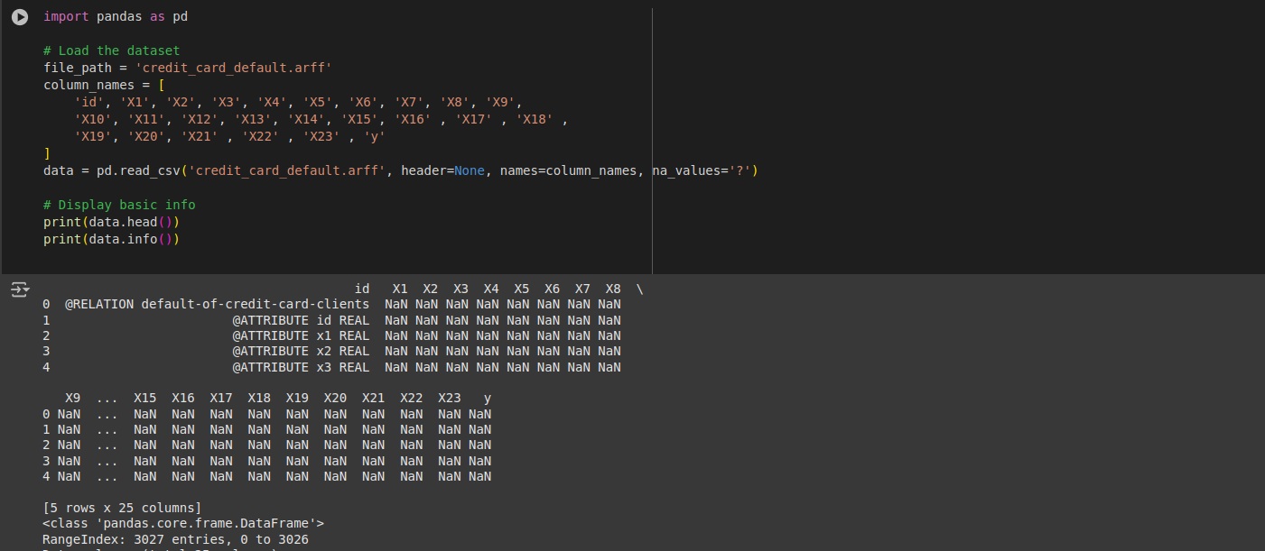

1.2) Handling Missing Values:

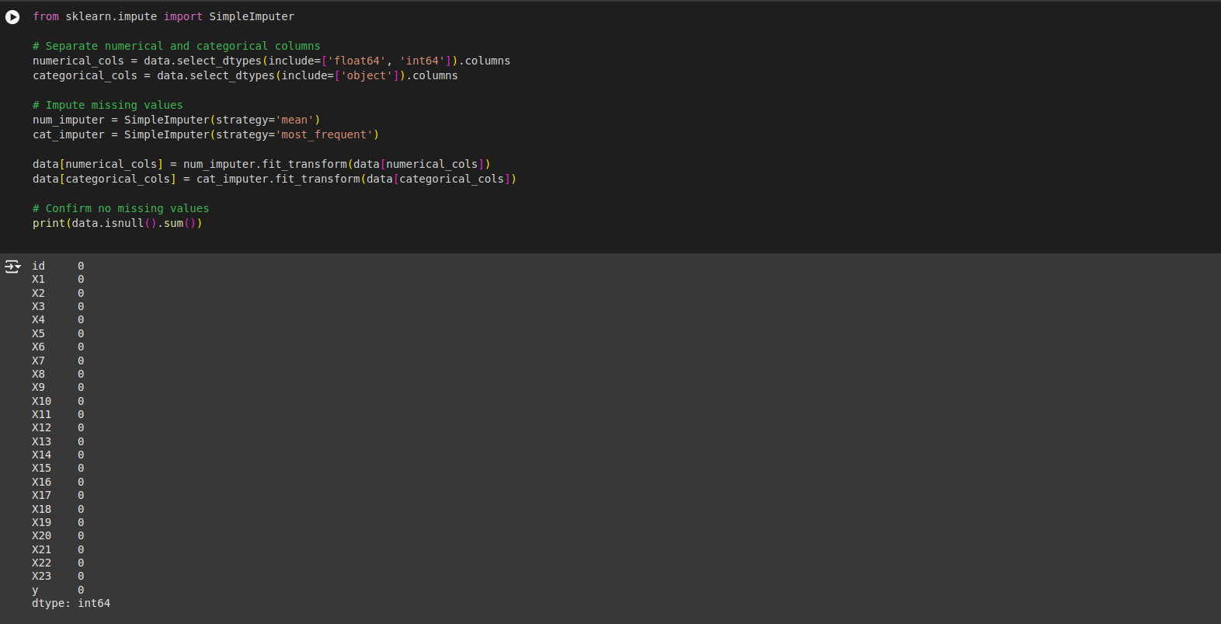

2) EDA :
2.1) Understand Data Distribution
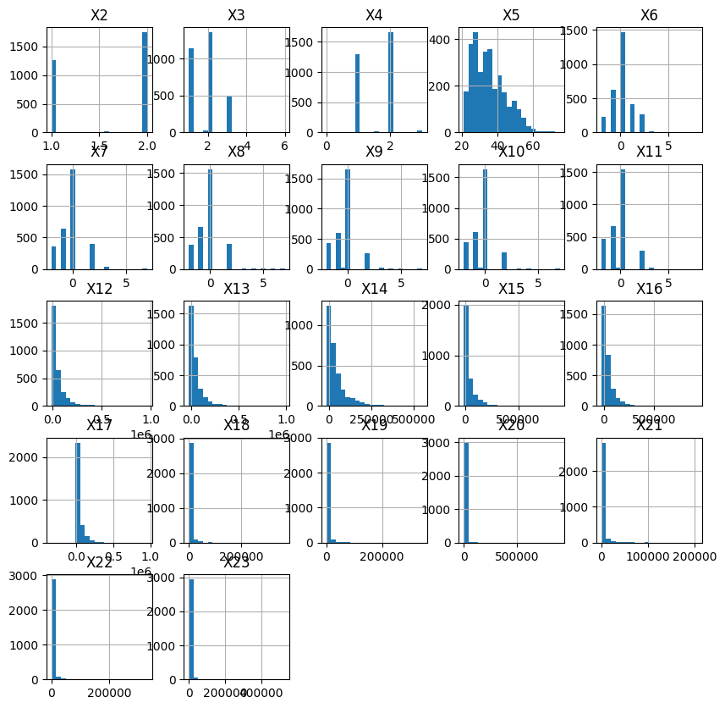
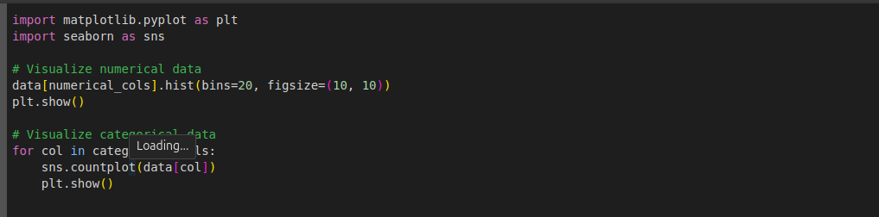

2.2) Class balance

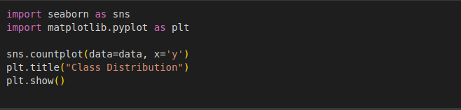

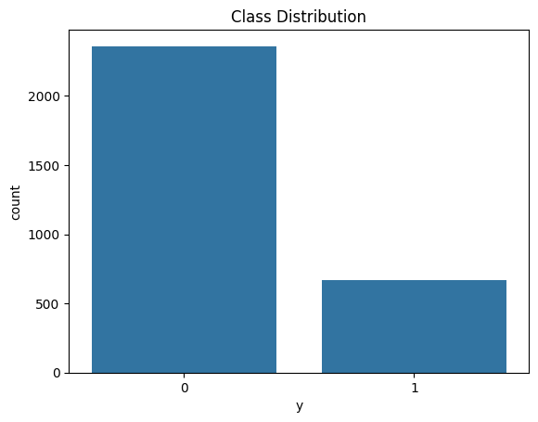

2.4) Outlier Detection


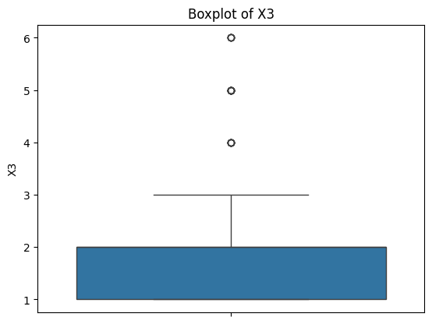

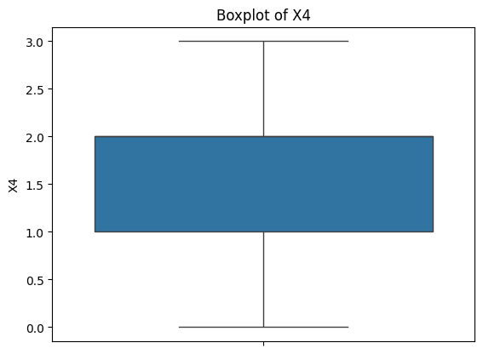

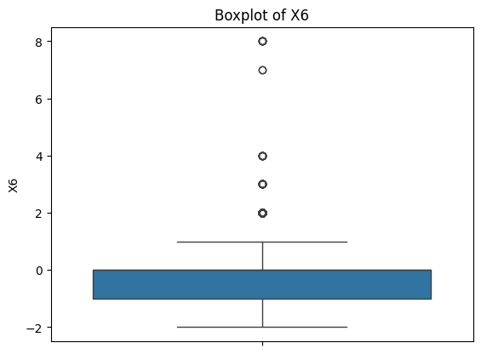

3) Train-test Split
3.1) Encode Categorical Data
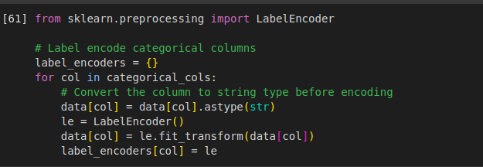
3.2) Split Data

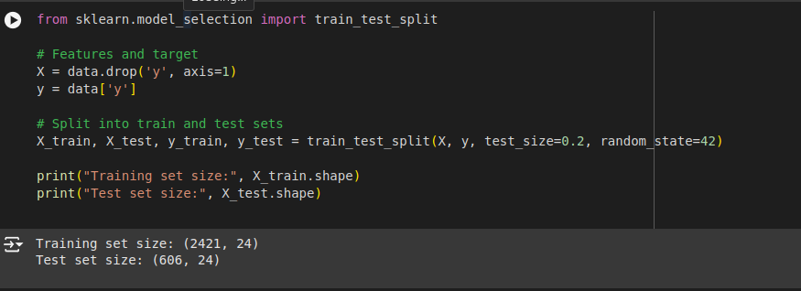

4) Applying ML Algorithms:
4.1) Logistic Regression
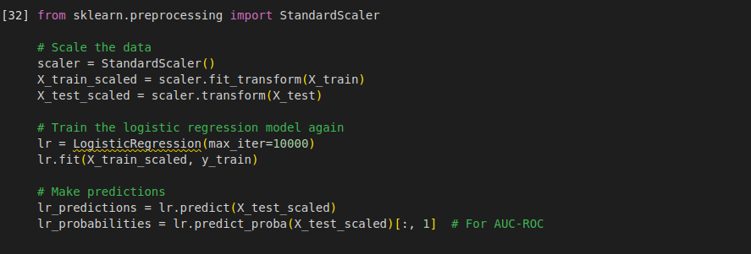

4.2)Decision Tree
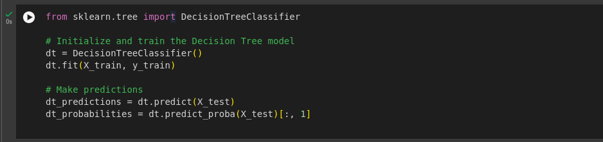

4.3) Random Forest

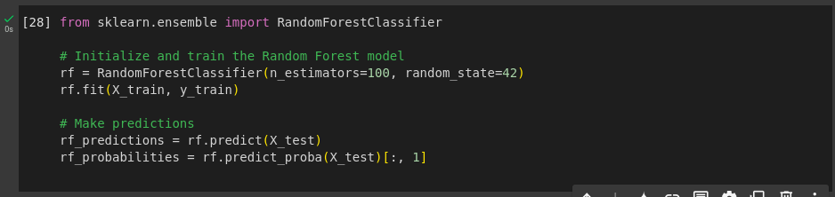

4.4) Gradient Boosting
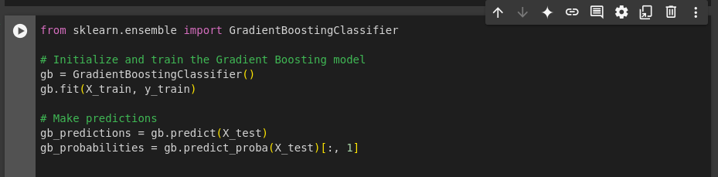

5) Evaluation Metrics

5.1) Evaluating Models

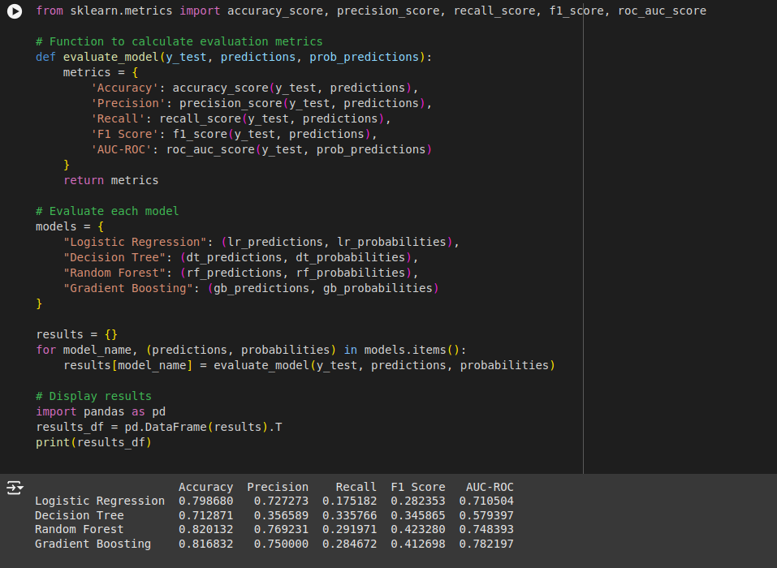

5.2) Plotting ROC Curves

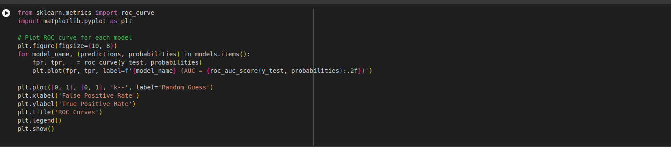

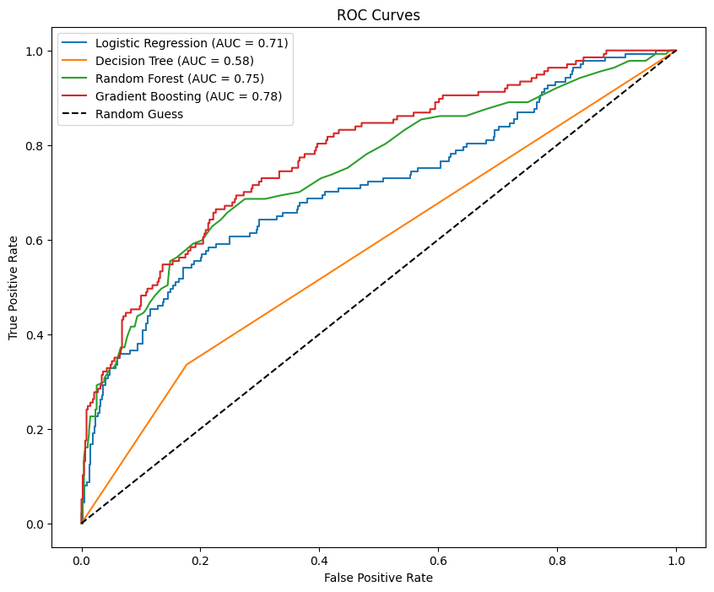
6) Comparing Results

Evaluation Metrics

• Accuracy: Overall correctness of predictions.
• Precision: Proportion of positive predictions that are actually positive.
• Recall: Proportion of actual positive cases correctly identified.
• F1-Score: Harmonic mean of precision and recall,
balancing both.
• AUC-ROC: Area Under the Receiver Operating Characteristic curve, measuring a model's ability to distinguish between positive and negative classes.
6.1)a) Logistic Regression

Accuracy: 0.796
Precision: 0.628
Recall: 0.718
F1 Score: 0.690
AUC-ROC: 0.690

b)Decision Tree

Accuracy: 0.711
Precision: 0.381
Recall: 0.405
F1 Score: 0.405
AUC-ROC: 0.605

c)Random Forest

Accuracy: 0.816
Precision: 0.645
Recall: 0.364
F1 Score: 0.466
AUC-ROC: 0.739

d)Gradient Boosting

Accuracy: 0.826
Precision: 0.700
Recall: 0.362
F1 Score: 0.477
AUC-ROC: 0.768

6.2) ROC Curves:
- Gradient Boosting has the highest AUC-ROC (0.77), indicating it performs better at distinguishing between the positive and negative classes.
- Random Forest follows with an AUC-ROC of 0.74, Logistic Regression is third with an AUC-ROC of 0.69,Decision Tree has the lowest AUC-ROC (0.61).

6.3) Model Selection

Balanced Metric: For a balance between precision and recall (measured by F1 Score), Logistic Regression performs the best (F1 Score: 0.690).

Ranking by AUC-ROC: Gradient Boosting > Random Forest > Logistic Regression > Decision Tree.

6.4) Conclusion

Gradient Boosting: Best choice if you prioritize overall model performance based on AUC-ROC and precision.

Logistic Regression: Preferred for a simpler model with good balance across metrics, especially for recall-focused applications.

